Wailea & Makena Magazine
Keiki Corner: February 2023
Written By:
Reading Specialist & long-time Teacher, Mrs. Michelle Lazuka M.Ed
What happened to our keiki's writing skills?

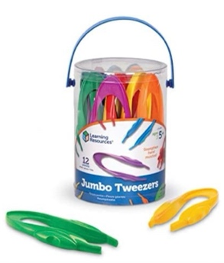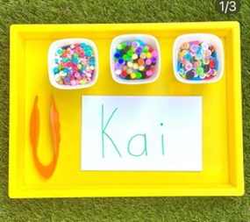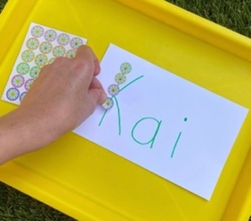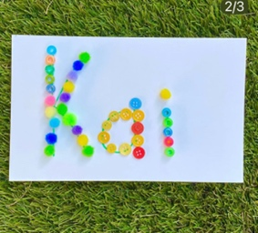

Aloha Maui caregivers. Recently, I have noticed many changes in the education system (after covid) that are having long term effects on children. Keiki are behind in their writing skills. Many children that have moved on to first, second & even third grade are tremendously lacking in this area. They did not completely develop their pincer grip or learn how to hold a pencil correctly. They also write letters incorrectly. This causes a delay in other areas of development. This concerns me because this, “problem,” is something that is easily preventable with the proper instruction and intervention during the PreK years of development.

Unfortunately, I am spending more time teaching children how to undo something they were already taught, when we could be moving forward and building on the basics. For example, some curriculums and philosophies suggest, “NOT” correcting a child when they are learning how to write. Meaning, if the child writes a letter or number incorrectly, the caregiver/teacher should not step in. I wholeheartedly disagree. They should step in, gently and with praise and encouragement to correct the behavior before the habit is formed. It is much harder to fix later than it is to develop correctly from the beginning.

Not to worry, as I said, catching this early on is key and can be prevented. I have loads of activities and tips for fine motor activities. Please do not hesitate to reach out for more advice, guidance or to borrow materials. I truly believe it takes a village J So please consider me a friendly resource that loves to help keiki in need.

A Fun Fine Motor Lesson To Do At Home:
This simple and super fun lesson can be made from things you already have at home. Pictured above. The tweezers are awesome for a variety of uses and activities. They are only about $10.00 on amazon right now and worth it!

*Easy activity you can do with just about anything: cereal, coins, stickers, buttons, paperclips, noodles etc.
*Use your pincer grip or use a tool/tweezers. This lesson can teach so much!
Concentration
Name writing
Letter recognition & sounds
Pencil grip
Fine motor strength
Patterns
Counting
Focus
And more…
*There are many extensions you can do with this lesson for older children as well. Practice last name, sight words, silent e, diphthongs & blends!

Mahalo for reading! LOVE LEARN ALOHA
Mrs. Lazuka

